Project Development Phase
Model Performance Test

Date | 19 February 2026
Team ID | LTVIP2026TMIDS52481
Project Name | Dog Breed Identification using Transfer Learning
Maximum Marks | 10 Marks

Model Performance Testing:
Project team shall fill the following information in model performance testing template.
S.No. | Parameter | Values | Screenshot
 | Metrics | Classification Model: Accuracy Score, Confusion Matrix, and Classification Report are used to evaluate dog breed prediction performance. The trained MobileNetV2 transfer learning model achieved high accuracy on validation data, confirming reliable multiclass classification. | 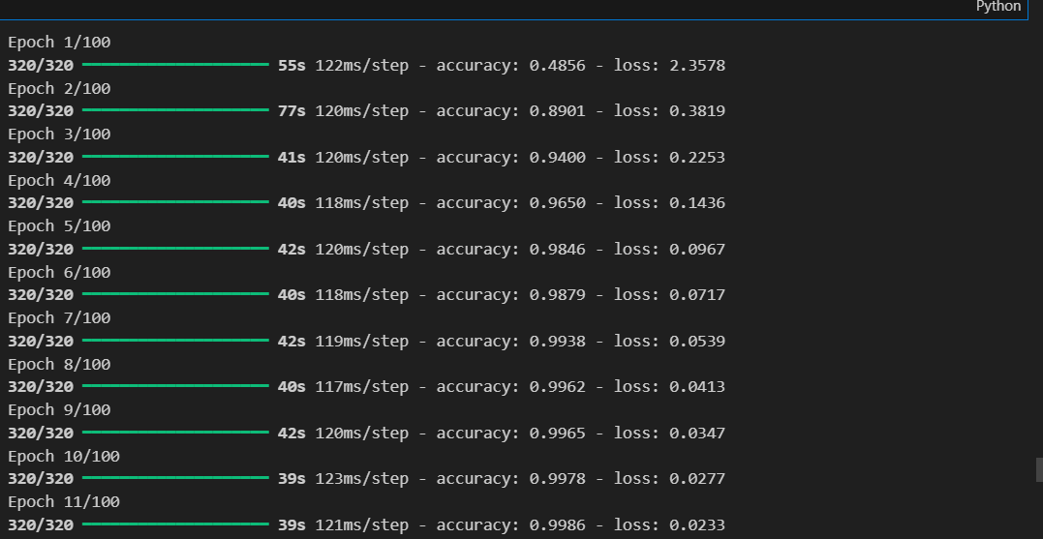
 | Tune the Model | hyperparameter Tuning: Learning rate, batch size, and number of epochs adjusted to improve accuracy and reduce overfitting.  Validation Method: Train–validation split with early stopping to ensure generalization. | 